Wind Power Project Project - Introduction
Design, test and redesign the best wind turbine blade you can to help solve the world’s energy problems!
Solo Project or a team of 2
This project is our attempt to tackle one of the world’s most important issues – finding a supply of energy that won’t run out and does not pollute our planet with harmful greenhouse gasses. For this project, you will be using model wind turbines to design, build and test the best wind turbine blade you can.
This project will include each part of the Research – Design – Create – Evaluate model. First, you should research all about wind turbines and write up what you learned in a short design brief (about 300 words). In your brief you must include:
- Problems which can be solved by using wind turbines
- What is a greenhouse gas and why is it dangerous?
- Basic wind turbine shapes and why they work
- Materials real-world wind turbines are made out of
- The best places in the U.S. and the World for using wind turbines (maybe the ocean?)
- What is a “Volt”, an “Amp” and a “Watt”
Then, you should come up with a plan of action. Your plan should include a detailed list of design criteria as well as several different blueprints for blade designs. Your blueprints should include both size (scale) and what your blade will be made out of. Your plan also needs a plan for testing which explains what your ideas for how you will construct, test, and redesign and retest your blades. This helps keep your main goals in mind while you work.
As you test, you should keep a testing log which records what you are testing and the results of each test. Your goal is to try and improve your blade each time. You should organize your testing log into a table which includes your independent and dependent variables for each test. You should do multiple tests, trying to improve the energy generated each time. Remember:
- Independent variable – This is the one you are changing/testing (for example, how long the blade is).
- Dependent variable – This is the one you are measuring (for example, amount of electrical power produced)
Remember, your goals are to write a short design brief on your research, come up with plan of action including blueprints and a testing plan, keep a testing log as you test your blades, and test your blades multiple times to try and find the best design.
There is more information on the back of this page!!!!!!

Project Brief
- Your primary goals are to:
  - Write a short design brief on your research:

  - Extensively plan including blueprints and a testing plan:

  - Test various independent variables to find what makes the best wind turbine blade:
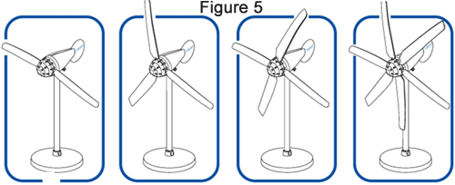
  - Keep a testing log as you test your blade design:
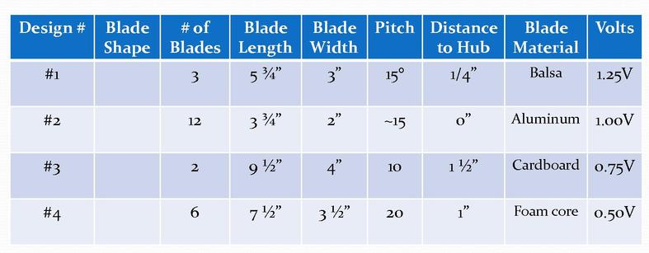

Getting started
Your first job is to convince Mr. Simonds that you can handle doing this project. To do that, you must answer these questions (you may type or write your answers on a separate sheet of paper):
- What is your research plan?
  - What questions do you need to answer?
  - What are some websites you can use?
  - Who are some people you could ask to support your work?
- What resources will you need to be successful?
  - What supplies in the room will you need?
  - Will you need anything from outside of the classroom?
  - Do you need to ask Mr. Simonds to get anything from the store?
- What are some basic design specifications that you will use?
  - In other words, what are some specific ideas you have about what a successful project will look like? Mr. Simonds recommends a checklist.
  - Your list won’t be complete until you finish your research, but you should at least start thinking about what success will look like.

Turn in the answers to these questions so Mr. Simonds can give you the OK!

